**Random Forest Algorithm**

**1. Introduction to Random Forest**

Random Forest is a powerful ensemble learning method used for classification and regression tasks. It is an extension of the Decision Tree algorithm that combines multiple decision trees to produce a more accurate and stable prediction.

**2. How Random Forest Works**

Random Forest builds multiple decision trees and merges their predictions to obtain a final result. The key principles behind it include:

* 1. **Bootstrapping (Bagging)**:
     + The algorithm selects random samples (with replacement) from the original dataset.
     + Each sample is used to train an individual decision tree.
  2. **Feature Randomness (Random Subspace Method)**:
     + Instead of considering all features while splitting a node, Random Forest selects a random subset of features.
     + This decorrelates the trees, reducing variance and preventing overfitting.
  3. **Majority Voting or Averaging**:
     + For classification: The final prediction is based on majority voting from all trees.
     + For regression: The final prediction is the average of all tree outputs.

**3. Steps to Build a Random Forest**

* 1. **Select Random Samples**: Randomly choose subsets of data (bootstrap sampling).
  2. **Grow Decision Trees**: Train multiple decision trees independently.
  3. **Random Feature Selection**: At each split in the tree, a random subset of features is considered.
  4. **Aggregate Predictions**:
     + **Classification**: Take majority vote.
     + **Regression**: Take the average of predictions.

**4. Advantages of Random Forest**

✅ **Handles Overfitting**: Reduces overfitting by averaging multiple trees.  
✅ **High Accuracy**: Performs well on large datasets with complex relationships.  
✅ **Works with Missing Values**: Can handle missing values using median/mode imputation.  
✅ **Feature Importance**: Provides insights into feature importance.  
✅ **Handles Large Datasets**: Scales well with a large number of samples and features.

**5. Disadvantages of Random Forest**

❌ **Computationally Expensive**: Requires more time and memory compared to single decision trees.  
❌ **Less Interpretability**: Unlike a single decision tree, a Random Forest model is harder to interpret.  
❌ **Bias in Imbalanced Data**: May not perform well on highly imbalanced datasets without adjustments.

**6. Random Forest Implementation in Python**

We can implement a Random Forest using the sklearn.ensemble.RandomForestClassifier for classification and sklearn.ensemble.RandomForestRegressor for regression.

**6.1 Random Forest for Classification**

**Import Necessary Libraries**

import numpy as np

import pandas as pd

import matplotlib.pyplot as plt

import seaborn as sns

from sklearn.model_selection import train_test_split

from sklearn.ensemble import RandomForestClassifier

from sklearn.metrics import accuracy_score, classification_report, confusion_matrix

**Load dataset (Example: Iris dataset)**

df = sns.load_dataset("iris")

print(df.to_string())

**Select Feature and Target Variables**

X=df.drop("species",axis=1)

y=df["species"]

**Split Dataset into Train and Test Set**

X_train, X_test, y_train, y_test = train_test_split(X, y, test_size=0.2, random_state=42)

**Initialize and train the model**

rf_classifier = RandomForestClassifier(n_estimators=100, random_state=42)

rf_classifier.fit(X_train, y_train)

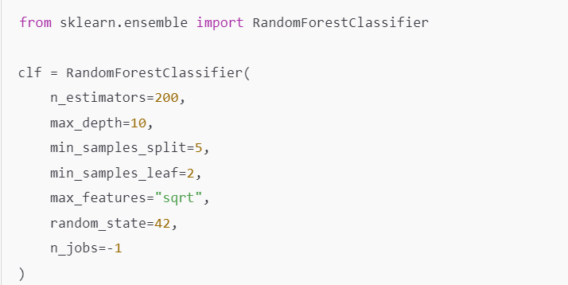

**Make Predictions based on test Dataset**

y_pred = rf_classifier.predict(X_test)

**Evaluate Model's Performance using Performance Metrics**

accuracy=accuracy_score(y_test,y_pred)

print(f"The Accuracy of the Classification Model :{accuracy : 0.2f}")

print("Classification Report : \n")

print(classification_report(y_test,y_pred))

**Model Output :**

**The Accuracy of the Classification Model :** 1.00

**Classification Report :**

|  |  |  |  |  |
| --- | --- | --- | --- | --- |
|  | **Precision** | **Recall** | **F1-Score** | **Support** |
| **Setosa** | 1.00 | 1.00 | 1.00 | 10 |
| **Versicolor** | 1.00 | 1.00 | 1.00 | 9 |
| **Virginica** | 1.00 | 1.00 | 1.00 | 11 |
| **Accuracy** |  |  | 1.00 | 30 |
| **Macro Avg** | 1.00 | 1.00 | 1.00 | 30 |
| **Weighted Avg** | 1.00 | 1.00 | 1.00 | 30 |

**Confusion Matrix :**

cm=confusion_matrix(y_test, y_pred)

plt.figure (figsize=(7,5))

sns.heatmap(cm,annot=True, fmt="d")

plt.title("Confusion Matrix")

plt.xlabel("Predicted Label")

plt.ylabel("Actual Label")

plt.show()

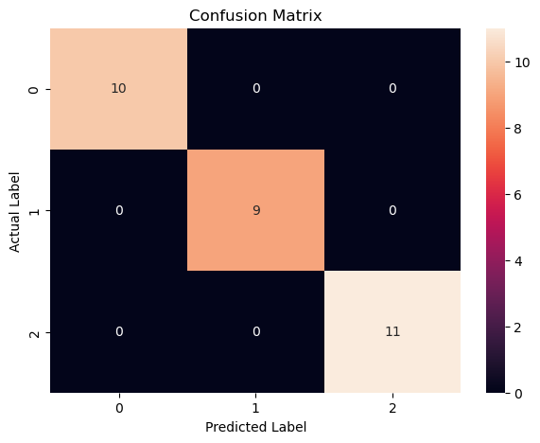

**Conclusion :**

* **Accuracy :** The model's accuracy is 1.00 which implies the model correctly classified flowers into three species setosa, versicolor and virginica.
* **Precision :** Out of all the flowers predicted as setosa,versicolor and virginica,the model's prediction is 100% correct for all the three flower species setosa,versicolor and virginica.
* **Recall :** Out of all the flower species the model's prediction is 100% correct for all the three flower species setosa, versicolor and virginica.
* **F1-Score :** Harmonic Mean of Precision and Recall
* **Support :** In the test dataset, there are 10 flowers of setosa,9 flowers of versicolor & 11 flowers of virginica.

**6.2 Random Forest for Regression**

python

CopyEdit

from sklearn.ensemble import RandomForestRegressor

from sklearn.metrics import mean_squared_error

# Load dataset (Example: Boston Housing dataset)

from sklearn.datasets import fetch_california_housing

data = fetch_california_housing()

X = data.data

y = data.target

# Split data

X_train, X_test, y_train, y_test = train_test_split(X, y, test_size=0.2, random_state=42)

# Initialize and train the model

rf_regressor = RandomForestRegressor(n_estimators=100, random_state=42)

rf_regressor.fit(X_train, y_train)

# Predict and evaluate

y_pred = rf_regressor.predict(X_test)

mse = mean_squared_error(y_test, y_pred)

print(f"Random Forest Regression MSE: {mse:.2f}")

**7. Tuning Hyperparameters in Random Forest**

Some important hyperparameters to tune:

* 1. **n_estimators**: Number of trees in the forest (default is 100).
  2. **max_depth**: Maximum depth of each tree (controls overfitting).
  3. **min_samples_split**: Minimum number of samples required to split an internal node.
  4. **min_samples_leaf**: Minimum number of samples required to be at a leaf node.
  5. **max_features**: Number of features to consider for each split (e.g., sqrt for classification).
  6. **bootstrap**: Whether to use bootstrap samples (default is True).

Example of Hyperparameter Tuning using GridSearchCV:

python

CopyEdit

from sklearn.model_selection import GridSearchCV

param_grid = {

'n_estimators': [100, 200, 300],

'max_depth': [10, 20, None],

'min_samples_split': [2, 5, 10]

}

grid_search = GridSearchCV(RandomForestClassifier(), param_grid, cv=5, scoring='accuracy')

grid_search.fit(X_train, y_train)

print("Best Parameters:", grid_search.best_params_)

**8. Feature Importance in Random Forest**

Random Forest can determine feature importance based on how much each feature contributes to reducing impurity.

python

CopyEdit

import matplotlib.pyplot as plt

# Get feature importances

feature_importances = rf_classifier.feature_importances_

# Plot feature importances

plt.barh(iris.feature_names, feature_importances)

plt.xlabel("Feature Importance Score")

plt.ylabel("Features")

plt.title("Feature Importance in Random Forest")

plt.show()

**9. Random Forest vs Decision Tree**

| **Feature** | **Decision Tree** | **Random Forest** |
| --- | --- | --- |
| **Overfitting** | High | Low |
| **Accuracy** | Moderate | High |
| **Computational Cost** | Low | High |
| **Interpretability** | Easy | Difficult |
| **Stability** | Sensitive to small changes in data | More stable |

**10. When to Use Random Forest**

* 1. When you need high accuracy and can afford computational cost.
  2. When the dataset is large with many features.
  3. When interpretability is not the primary concern.
  4. When you need feature importance analysis.

**Conclusion**

Random Forest is an excellent ensemble learning technique that enhances the accuracy and stability of predictions while preventing overfitting. It is widely used in machine learning applications, such as fraud detection, medical diagnosis, and recommendation systems.

Would you like me to elaborate on any part of this explanation? 😊

4o

Top of Form

Bottom of Form